**Problem Statement- 1 :- Explore , Execute and Analyze general purpose Linux commands.**

**1.1**  Use a command lo list all files, including hidden ones, in the current working directory.

**1.2**  Show the full path of your current working directory.

**1.3**  Create a new directory called MyFolder.

**1.4**  Change the current directory to MyFolder.

**1.5**  Delete the directory MyFolder.

**1.6**  Copy file1.txt to file2.txt.

**1.7**  Rename file2.txt to file3.txt.

**1.8**  Delete file3.txt

**1.9**  Use a command to display system information, such as kernel name and version.

**1.10** Create an empty file named test.txt.

**1.11** Clear the terminal screen.

**1.12** List all currently running process.

**1.13** Search for the word “Linux” in the file example.txt

**1.14** Use a command to display “Welcome to Linux” on the terminal

**1.15** Display the disk usage of all mounted file systems.

**1.16** Use a command to count lines, word, and characters in test.txt.

**1.17** Display the current user name.

**1.18** Command to sort the output of file in reverse order.

**Objective:** To understand and effectively utilize general purpose Linux commands for system management, file manipulation and task automation. This includes mastering commands for navigating directories, managing files and permissions , monitoring system performance and executing basic scripting task to enhance productivity and streamline workflows in a Linux environment.

**1.1** Use a command lo list all files, including hidden ones, in the current working directory.

**Command:** ls -a

**Description:** The ls command is commonly used to identify the files and directories in the working directory.

**Output :**

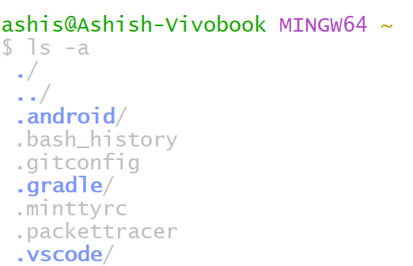

**1.2** Show the full path of your current working directory.

**Command:** pwd

**Description:** The pwd command is mostly used to print the current working directory on your terminal.

**Output :**

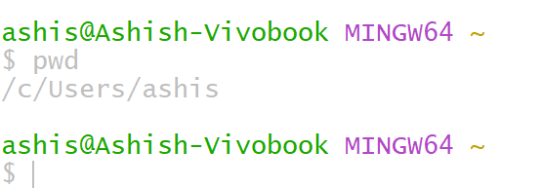

**1.3** Create a new directory called MyFolder.

**Command:** mkdir MyFolder

**Description:** The mkdir command allows you to create fresh directories in the terminal

**Output :**

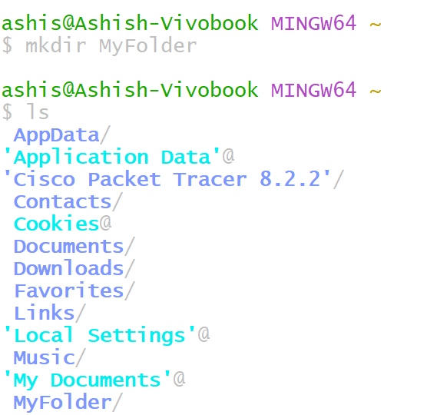

**1.4** Change the current directory to MyFolder.

**Command:** cd MyFolder

**Description:** The cd command allows you to change the directory in the terminal

**Output :**

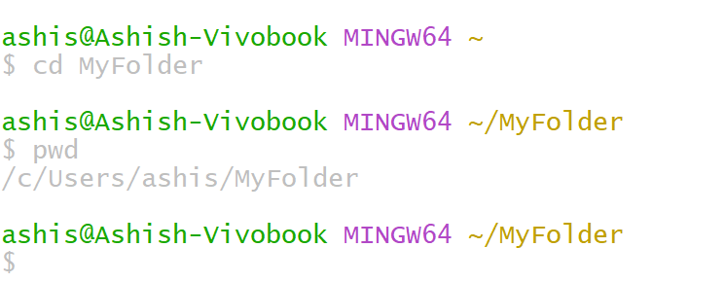

**1.5** Delete the directory MyFolder.

**Command:** rmdir MyFolder

**Description:** The rmdir command allows you to delete the directory in the terminal **Output :**

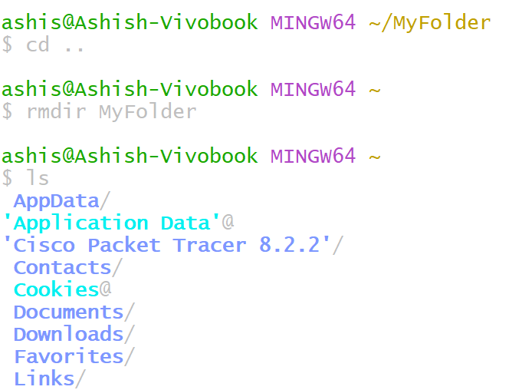

**1.6** Copy file1.txt to create file2.txt

**Command:** cp file1.txt file2.txt

**Description:** cp command copy the content of a file into another file

**Output :**

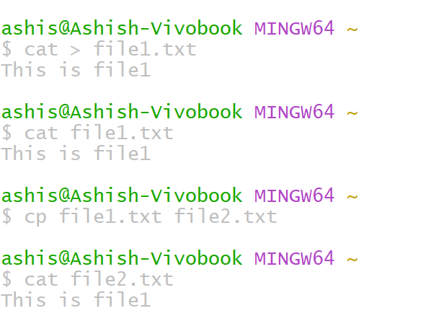

**1.7** Rename file2.txt to file3.txt

**Command:** mv file2.txt file3.txt

**Description:** mv command is used to rename a file in terminal.

**Output :**

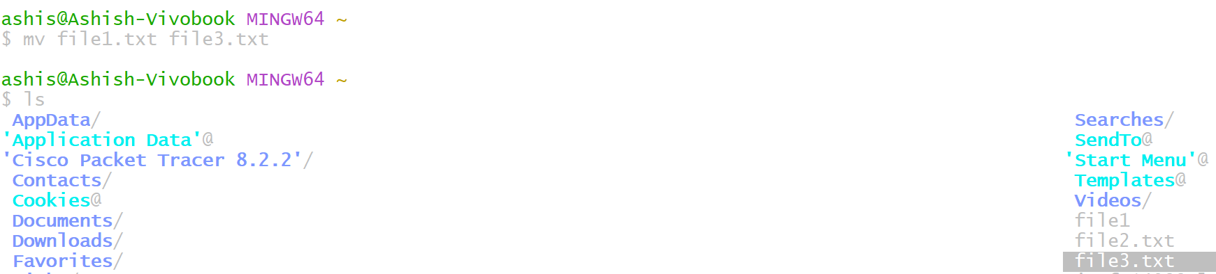

**1.8** Delete file3.txt

**Command:** rm file3.txt

**Description:** rm command is used to delete a file in terminal.

**Output :**

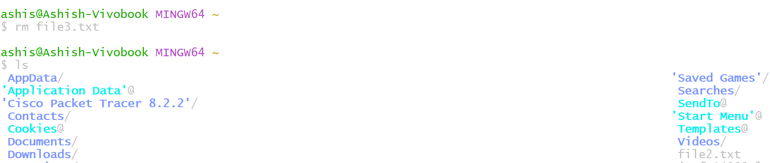

**1.9** Use a command to display system information , such as kernel name and version.

**Command:** uname -a

**Description:** uname command is used to display system information , such as kernel name and version

**Output :**

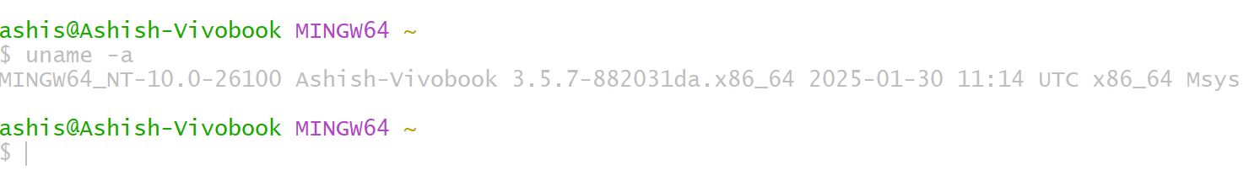

**1.10** Create an empty file named test.txt.

**Command:** touch test.txt

**Description:** touch command is used to create an empty file in terminal.

**Output :**

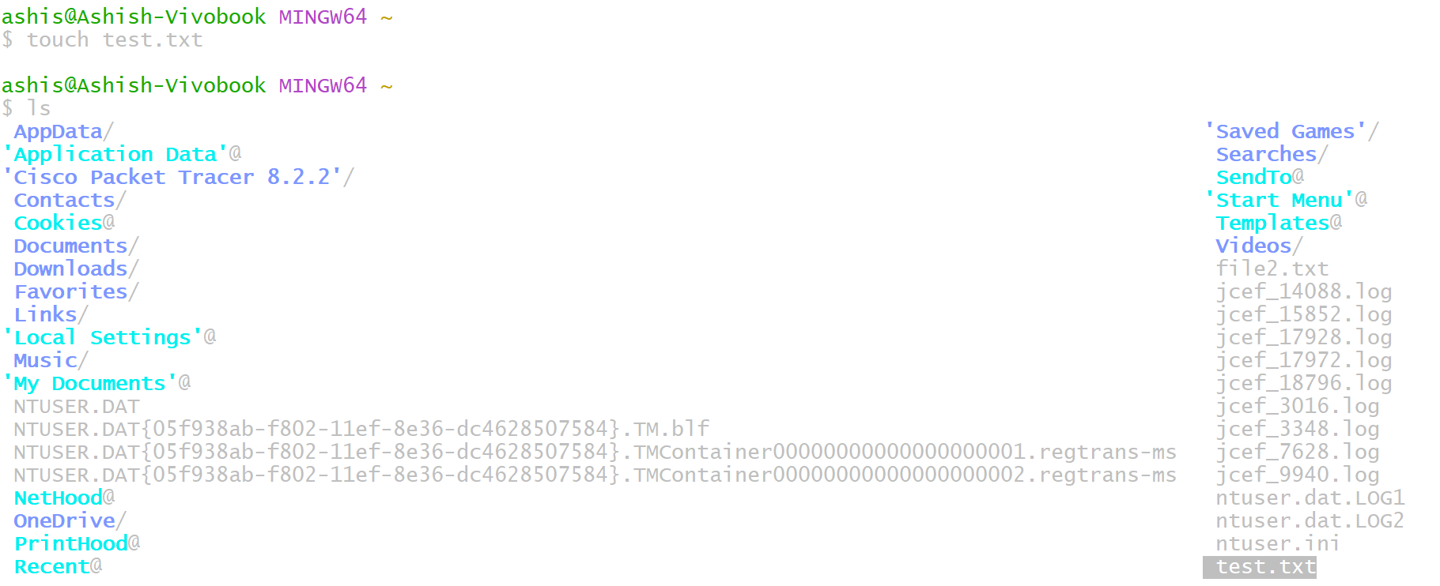

**1.11** Clear the terminal screen.

**Command:** clear

**Description:** clear command is used to clear the terminal screen

**Output :**

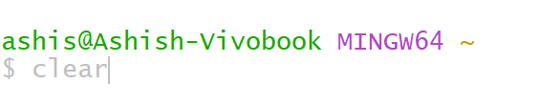

**1.12** List all currently running process

**Command:** ps

**Description:** ps command is use to list all currently running process in terminal

**Output :**

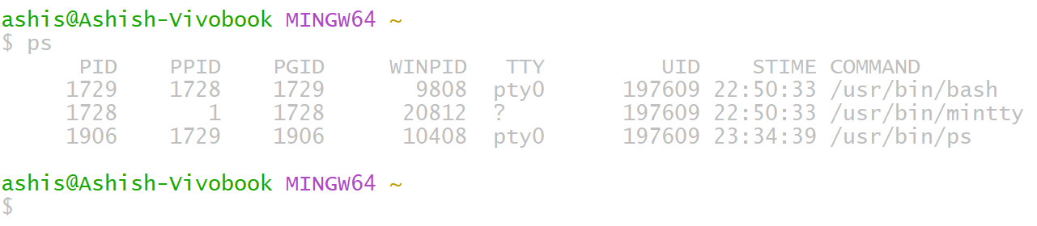

**1.13** Search for the word “Linux” in the file example.txt.

**Command:** grep “Linux” example.txt

**Description:** grep command is used to search a word in a file.

**Output :**

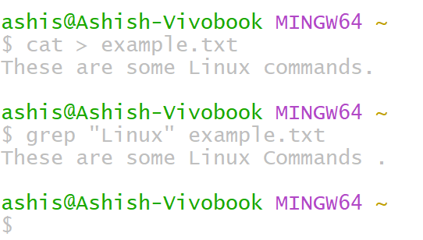

**1.14** Use a command to display “Welcome to Linux” on the terminal.

**Command:** echo “Welcome to Linux”

**Description:** echo command is used to display text on terminal screen.

**Output :**

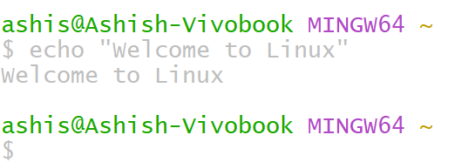

**1.15** Display the Disk usage of all mounted file system.

**Command:** df -h

**Description:** df command is used to check disk space usage of file system.

**Output :**

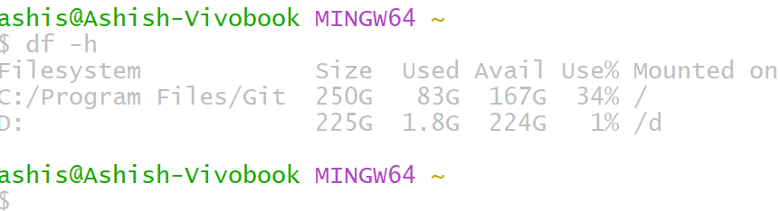

**1.16** Use a command to count lines , words ,and character in test.txt

**Command:** wc test.txt

**Description:** wc command is used to check lines , words and character in a file.

**Output :**

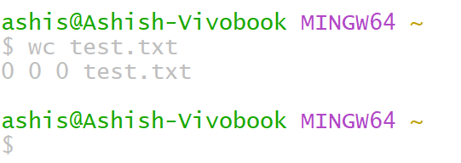

**1.17** Display the current username.

**Command:** whoami

**Description:** whoami command is used to display the current username.

**Output :**

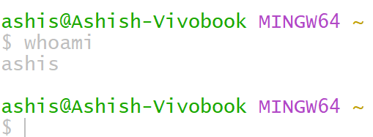

**1.18** Command to sort the output of a file in reverse order.

**Command:** ls | sort -r

**Description:** ls | sort -r command is used to sort the output in reverse order.

**Output :**

